The Most Magnificent Thing
April/May GATE Group

In April, I introduced the book: “The Most Magnificent Thing” by Ashley Spires, to our GATE students. They LOVED the story, and were very intrigued with the idea of building and engineering their own “magnificent” things.
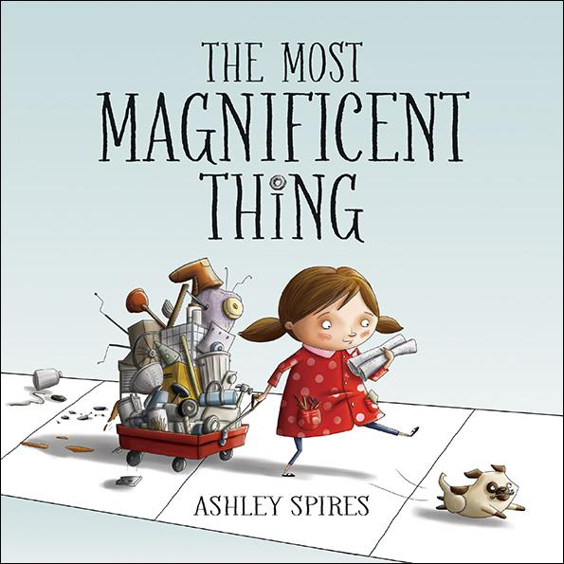
Here is a synopsis of the book:

The Most Magnificent Thing

Written by Ashley Spires
Illustrated by Ashley Spires

Award-winning author and illustrator Ashley Spires has created a charming picture book about an unnamed girl and her very best friend, who happens to be a dog. The girl has a wonderful idea. “She is going to make the most MAGNIFICENT thing! She knows just how it will look. She knows just how it will work. All she has to do is make it, and she makes things all the time. Easy-peasy!” But making her magnificent thing is anything but easy, and the girl tries and fails, repeatedly. Eventually, the girl gets really, really mad. She is so mad, in fact, that she quits. But after her dog convinces her to take a walk, she comes back to her project with renewed enthusiasm and manages to get it just right.
For the early grades' exploration of character education, this funny book offers a perfect example of the rewards of perseverance and creativity. The girl's frustration and anger are vividly depicted in the detailed art, and the story offers good options for dealing honestly with these feelings, while at the same time reassuring children that it's okay to make mistakes. The clever use of verbs in groups of threes is both fun and functional, offering opportunities for wonderful vocabulary enrichment. The girl doesn't just “make” her magnificent thing --- she “tinkers and hammers and measures,” she “smoothes and wrenches and fiddles,” she “twists and tweaks and fastens.” These precise action words are likely to fire up the imaginations of youngsters eager to create their own inventions and is a great tie-in to learning about Science, Technology, Engineering and Math.

After reading and discussing the book, we did a short activity where the students had to be creative and think about different uses for common, everyday items in their world. We used a piece of yarn, and students would pass the yarn around and have to say, “This isn’t a piece of yarn, it is a _______.” The object of the game was to be as creative as possible, and to make our minds step “outside the box” to come up with unique and inventive ideas that others didn’t think of.
This task wasn’t easy, at first, but as your children loosened up a bit, they really got inspired in their thinking.

For the month of May, our GATE group session will conclude the year with a building project of “Most Magnificent Things.” I have collected bags full of items in which teams of students will work together to use the contents to create, invent, and push themselves to engineer a “Most Magnificent Thing” to showcase to the rest of the group. The students will have one hour to do their creating, so there is a little pressure involved.
I am hoping to see teamwork, inspiration, creativity, but most of all perseverance. This whole project is more about the “process” of work versus the actual “product” of the work. I want them to understand that success in life is about hard work, time commitment, drive, creativity and teamwork.

I hope this project inspires your child to use his/her creativity in designing, inventing, creating, etc… out of junk just laying around the house. It’s amazing what cereal boxes, toilet paper tubes, old slinkies, yarn, newspaper, old toys, tape, etc…. can be engineered into.

